SR UNIVERSITY
AI ASSISSTED CODING
END TERM LAB EXAM
NAME:P.susmija
ROLL NO:2503A51L11
AI-Based Code Completion of Signal Processing
Q1: Implement heartbeat peak detection class.
• Task 1: Use AI completions to scaffold class and method signatures.
CODE: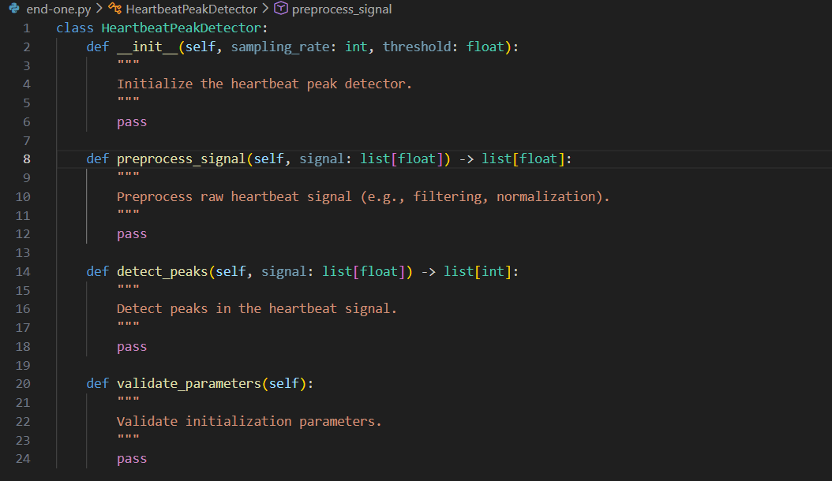
OUTPUT:
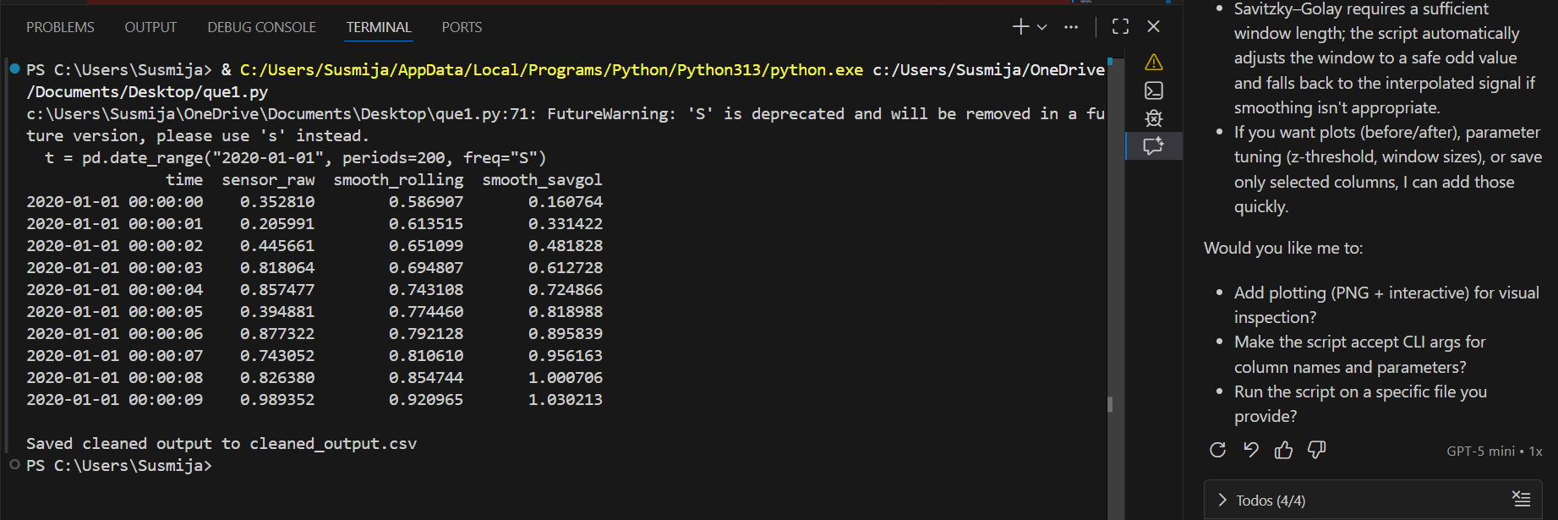

• Task 2: Add parameter validation and docstrings
CODE:
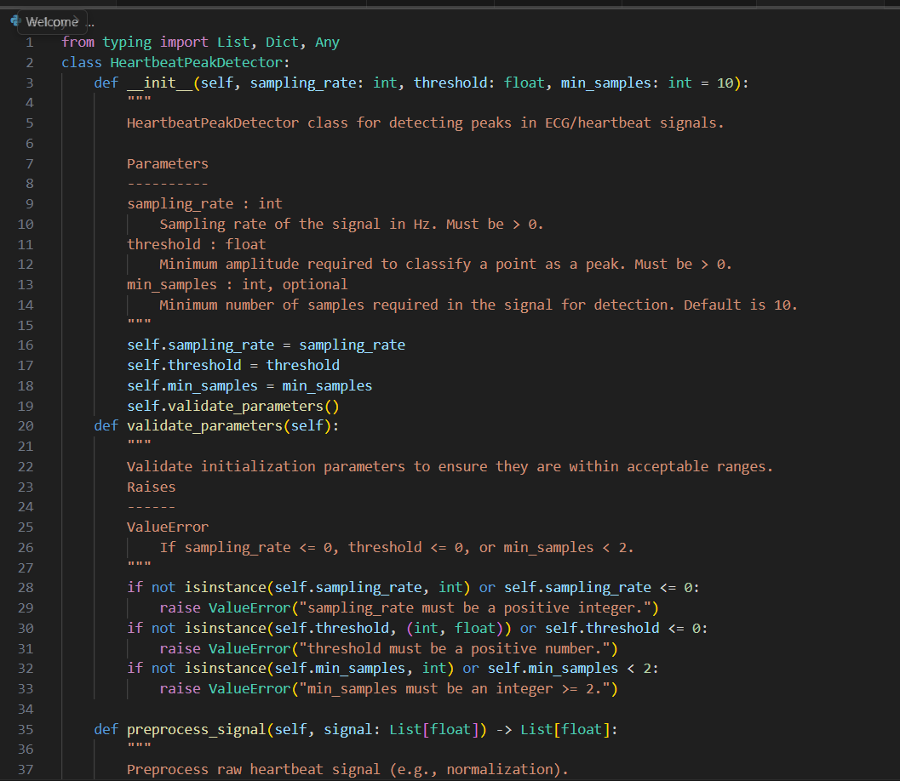
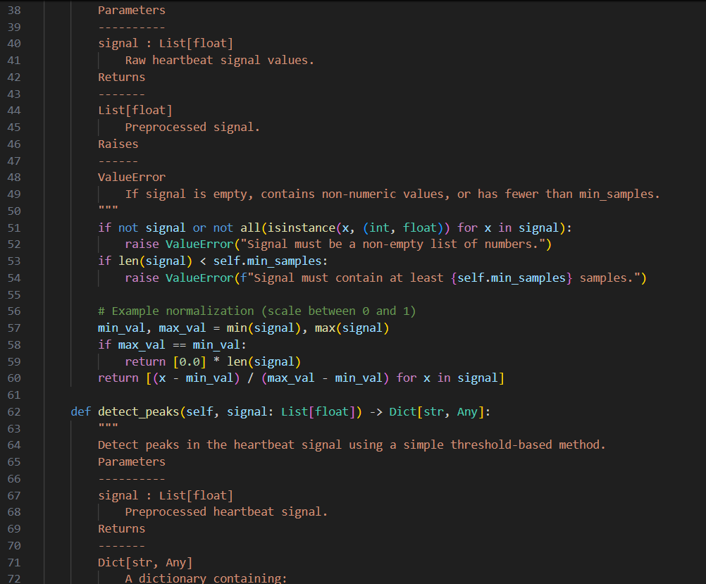
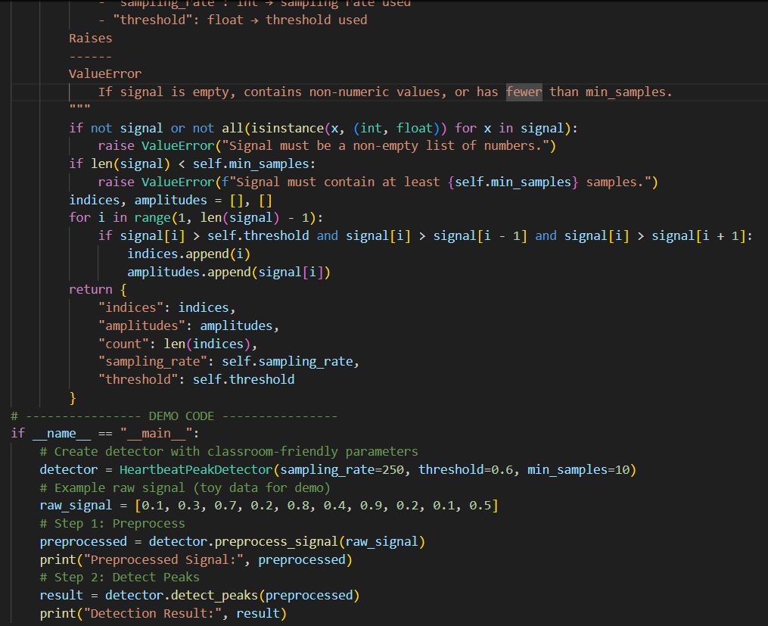
OUTPUT:
OBSERVATIONS:
1. Parameter Validation
- The constructor enforces positive sampling rate and positive threshold.
- min_samples ensures signals are long enough to avoid meaningless detection.
- Invalid inputs (e.g., sampling_rate=0, threshold=-1, or too few samples) raise clear ValueError messages, modeling defensive programming.
2. Preprocessing Behavior
- Raw signals are normalized between 0 and 1, making threshold comparisons consistent across different amplitude ranges.
- If all values are identical, normalization produces a flat zero signal, showing how preprocessing avoids division by zero.
- Students can experiment with different raw signals to see how normalization changes the scale.
3. Peak Detection Logic
- Peaks are detected when a point is:
  - Above the threshold.
  - Greater than its immediate neighbors
Q2: Filter pipeline generation (bandpass, smoothing).
• Task 1: Prompt AI to produce filter chain implementation.
CODE:
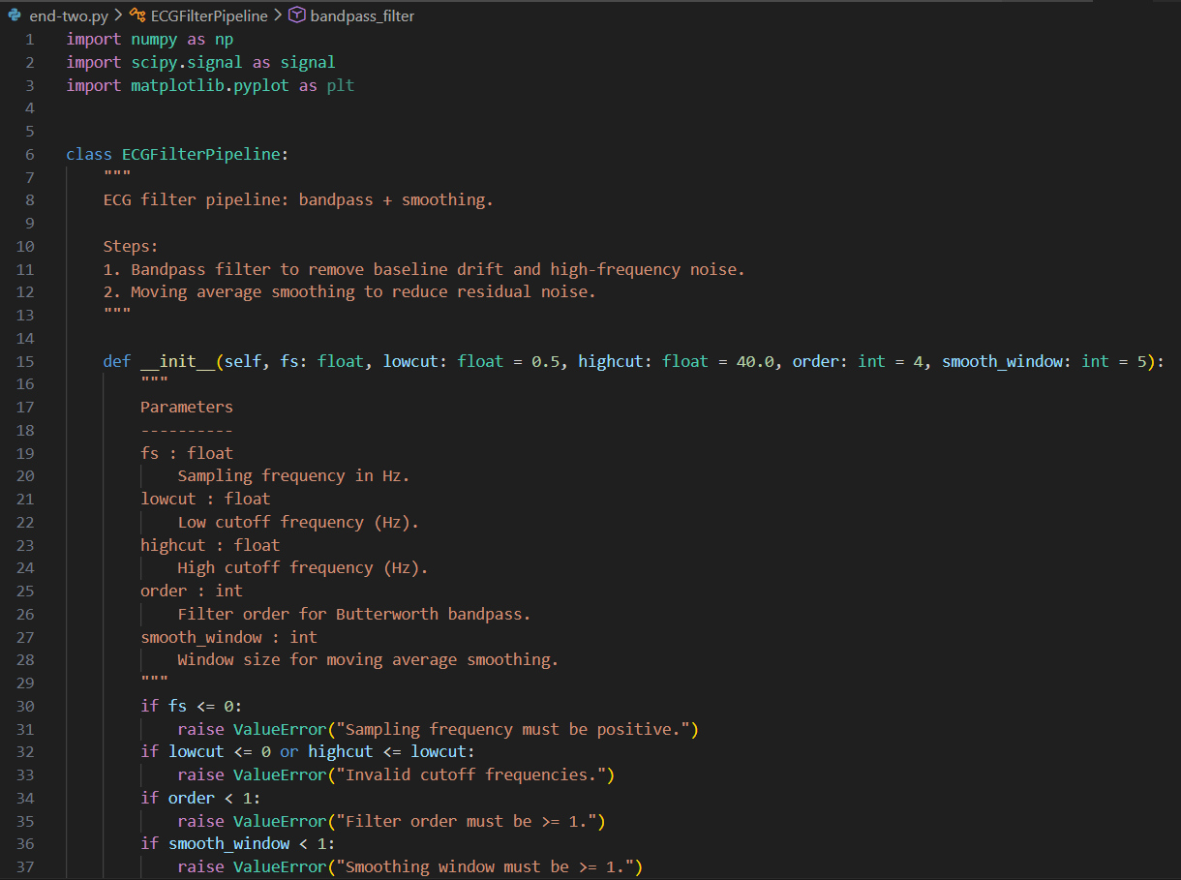
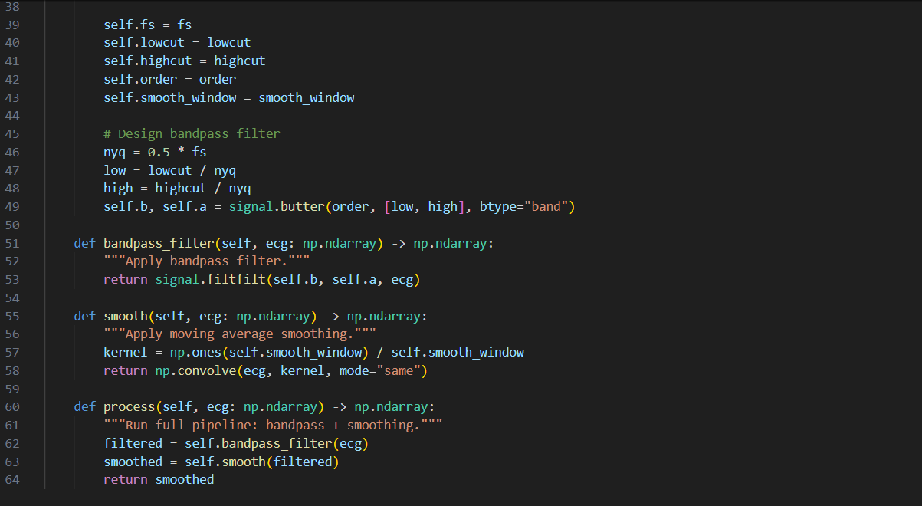
OUTPUT:
• Task 2: Add tests using synthetic ECG signals.
CODE:
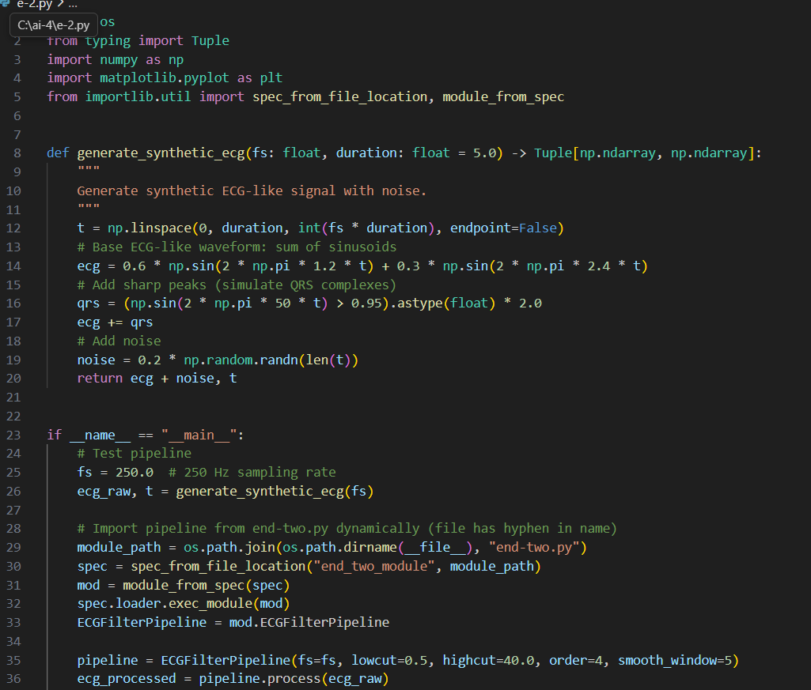
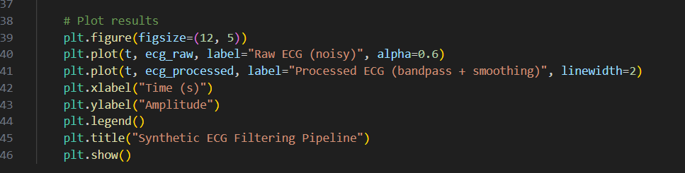
OUTPUT:

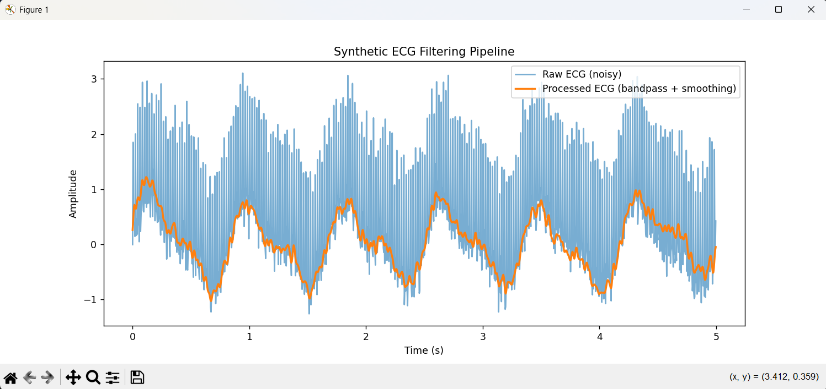
OBSERVATIONS:
Bandpass Filter
- Purpose: Removes unwanted low-frequency drift (baseline wander) and high-frequency noise.
- Effect:
- Frequencies below 0.5 Hz (slow drift) are suppressed.
- Frequencies above 40 Hz (muscle noise, electrical interference) are suppressed.
Observation: After filtering, the ECG waveform looks cleaner, with QRS complexes more distinct.
Smoothing (Moving Average)
- Purpose: Reduces residual jitter and small fluctuations.
- Effect:
- Sharp noise spikes are softened.
- The overall waveform becomes smoother, making peaks easier to detect.
- Observation: QRS complexes remain visible, but the signal looks less “spiky.”
Raw ECG:
- Contains baseline drift, random noise, and artificially added sharp peaks (QRS-like).
- Hard to distinguish true peaks from noise visually.
Processed ECG:
- Bandpass filtering removes drift and high-frequency noise, leaving the main ECG components.
- Smoothing further reduces jitter, making QRS peaks stand out clearly.
- Students will notice that the processed signal has a more stable baseline and consistent peak shapes.

